

EXPERIMENT REPORT

|  |  |
| --- | --- |
| **Experiment Name** | Linear Applications of Operational Amplifiers |
| **Lab Assistant** | Berat DOĞAN |
| **Author of the Report (Name / No / Department)** | Tuğrul YATAĞAN  040100117  Computer Engineering |
| **Group Number and**  **Experiment Date** | D27  15.11.2013 |

|  |  |  |
| --- | --- | --- |
| **Report Score** | **Deliver Date** | **Receive Date** |
|  | 22.11.2013 |  |

### Aim of the Experiment

In this experiment session, we investigate basic understanding of operational amplifiers (op-amps) for performing linear applications such as inverting amplifiers, non-inverting amplifiers and some mathematical functions.

### Exp #1 Inverting OP-AMP

We provide 2V peak to peak sinusoidal wave signal to input. R1 is 10k Ω resistor and R2 is a 100k Ω linear potentiometer. Since R2 is potentiometer, we can set various values for R2 and measure the peak to peak voltage of output signal from oscilloscope.

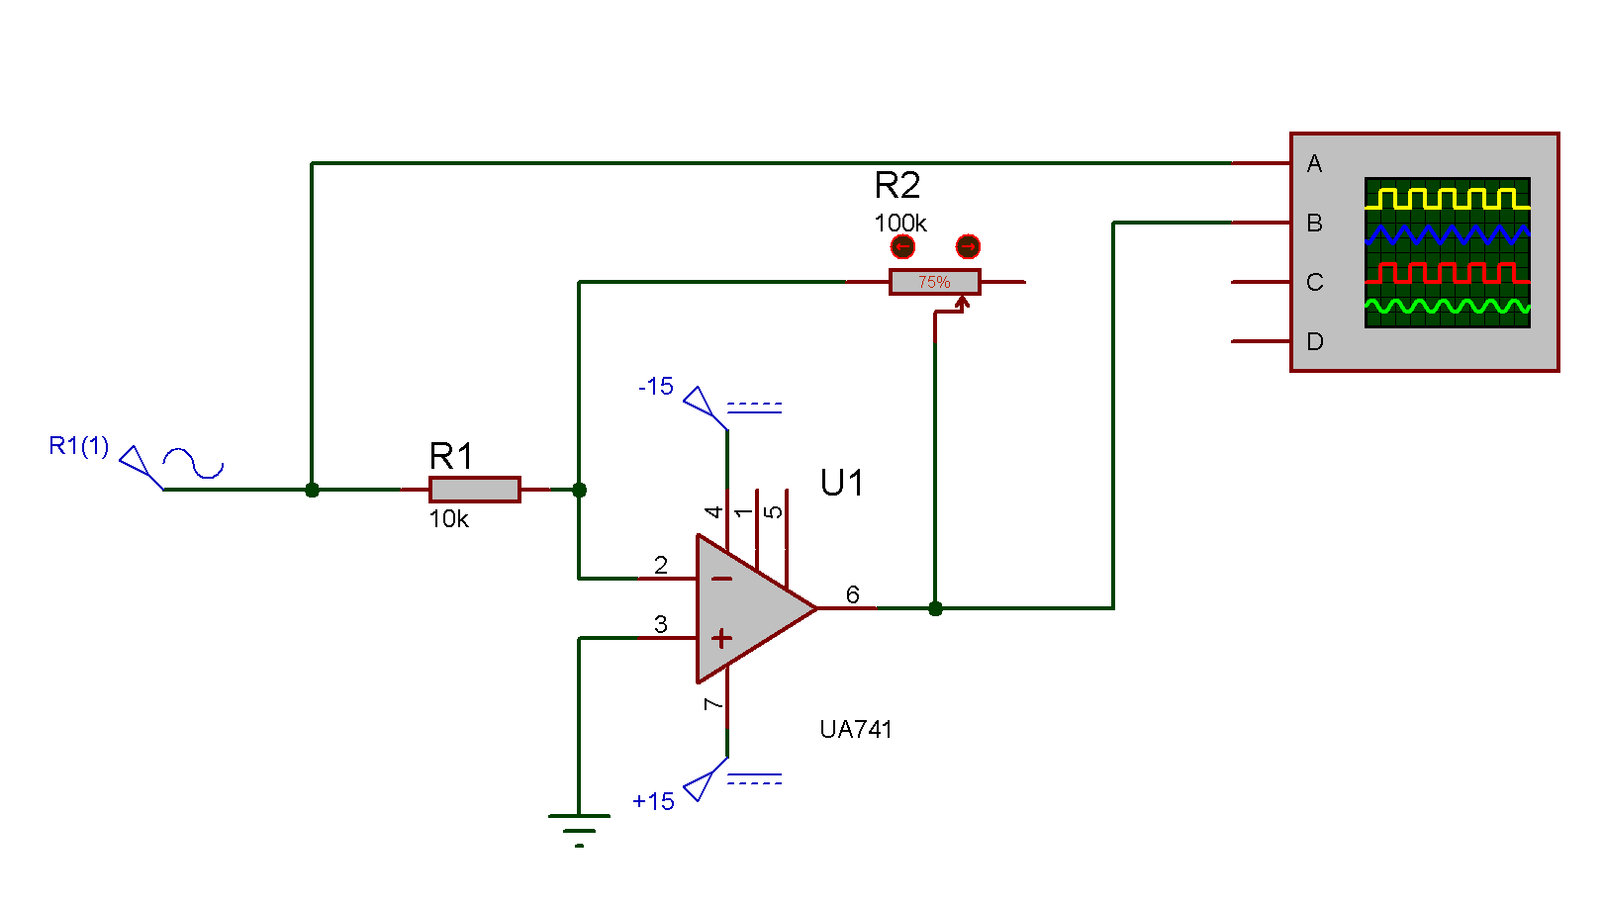

**Vin = 2V (Vpp)**

|  |  |  |
| --- | --- | --- |
| **R2(Ω)** | **Measured Vout (Vpp)** | **Theoretical Vout (Vpp)** |
| **100k** | 18.4 V | 20 V |
| **75k** | 14.4 V | 15 V |
| **50k** | 9.46 V | 10 V |
| **25k** | 2.54 V | 5 V |
| **10k** | 2 V | 2 V |

Theoretical Vout calculated from the voltage gain equation of the inverting amplifier circuit is:

$$\frac{V_{out}}{V_{in}}=-\frac{R_{2}}{R_{1}}$$

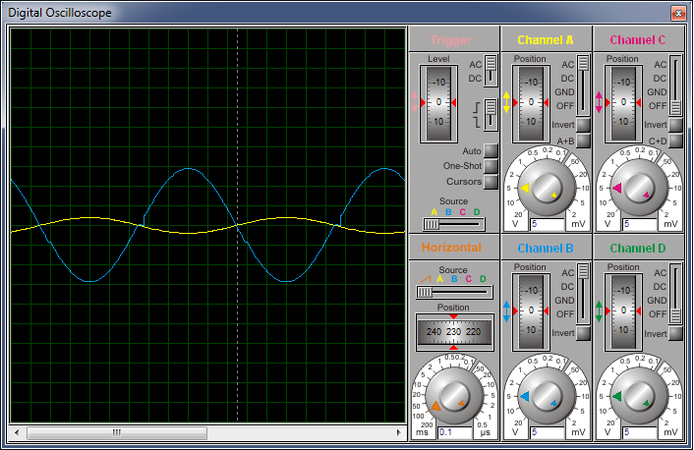

As can be seen in simulation oscilloscope screen, input signal (yellow line) is amplified and inverted to output signal (blue line).

### Exp #2 Non-Inverting OP-AMP

We provide 2V peak to peak sinusoidal wave signal to input like first experiment. R1 is 10k Ω resistor and R2 is a 100k Ω linear potentiometer. Since R2 is potentiometer, we can set various values for R2 and measure the peak to peak voltage of output signal from oscilloscope.

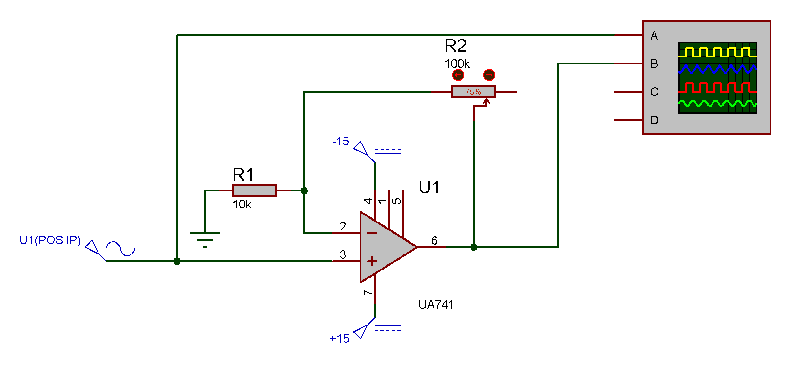

**Vin = 2V (Vpp)**

|  |  |  |
| --- | --- | --- |
| **R2(Ω)** | **Measured Vout (Vpp)** | **Theoretical Vout (Vpp)** |
| **100k** | 20.2 V | 22 V |
| **75k** | 16.6 V | 17 V |
| **50k** | 11.9 V | 12 V |
| **25k** | 6.91 V | 7 V |
| **10k** | 3.95 V | 4 V |

Theoretical Vout calculated from the voltage gain equation of the non-inverting amplifier circuit is:

$$\frac{V_{out}}{V_{in}}=1+\frac{R_{2}}{R_{1}}$$

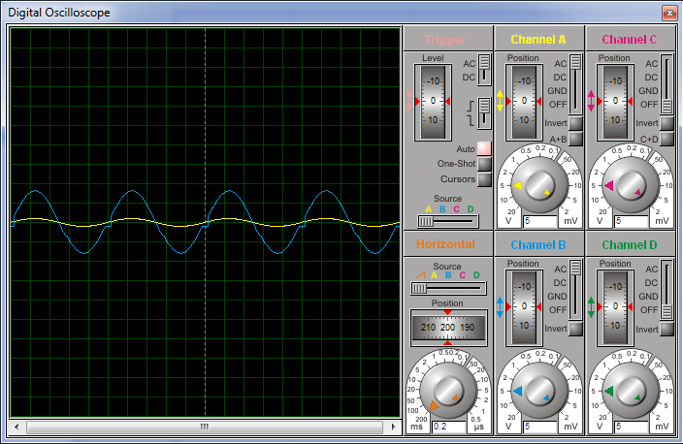

As can be seen in simulation oscilloscope screen, input signal (yellow line) is amplified and to output signal (blue line).

### Exp #3 Summing Amplifier

We provide 5V DC signal as V1 and 6V peak to peak sinusoidal wave signal as V2 to input. R1 is 8.2kΩ resistor, R2 is 2.7kΩ resistor and R3 is 8.2kΩ resistor for adjusting a = 1 and b = 3 in output equation;

$V_{o} = -\left(aV_{1}+bV_{2}\right)$ so;

$$V_{o} = -\left(V_{1}+3V_{2}\right)$$

Which is actually; the voltage gain equation of the summing amplifier:

$V_{o} = -\left(\frac{R_{3}}{R_{1}}V_{1}+\frac{R_{3}}{R_{2}}V_{2}\right)$

Then we measure the peak to peak voltage of output signal from oscilloscope.

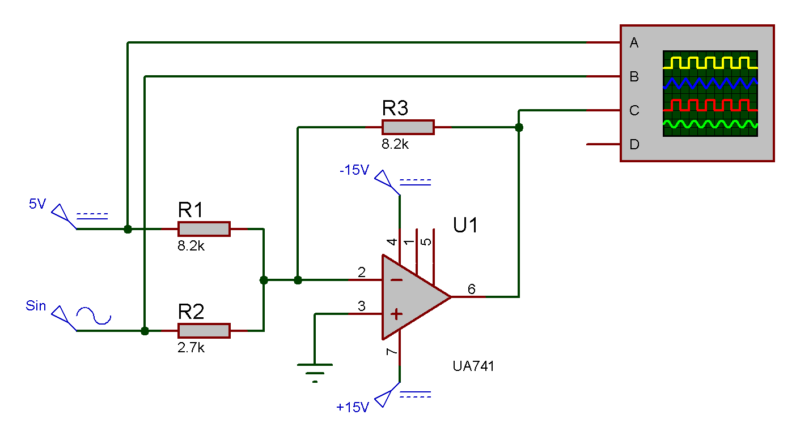

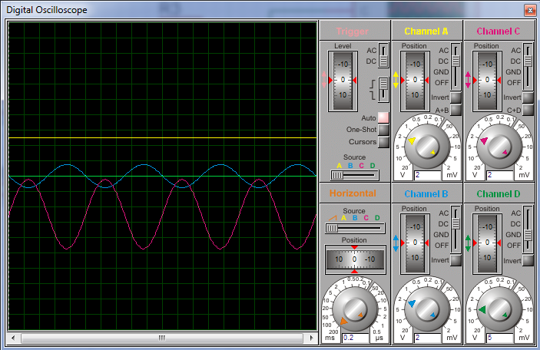

As can be seen in simulation oscilloscope screen; input signal 5V DC as V1 (yellow line), input signal 6V sinusoidal as V2 (blue line), ground (green line) and the output signal (purple line). Output is like inverted and amplified sinusoidal wave with 5V offset bellow the ground.

### Exp #4 OP-AMP Integrator

We provide 5V peak to peak square wave signal as Vin, R1 is 10kΩ resistor, R2 is 100kΩ resistor and Req is 10kΩ resistor for adjusting voltage equation of the op-amp integrator.

$$V_{o} = -\frac{1}{RC}\int{V_{1}dt+ V_{o(t=0)}}$$

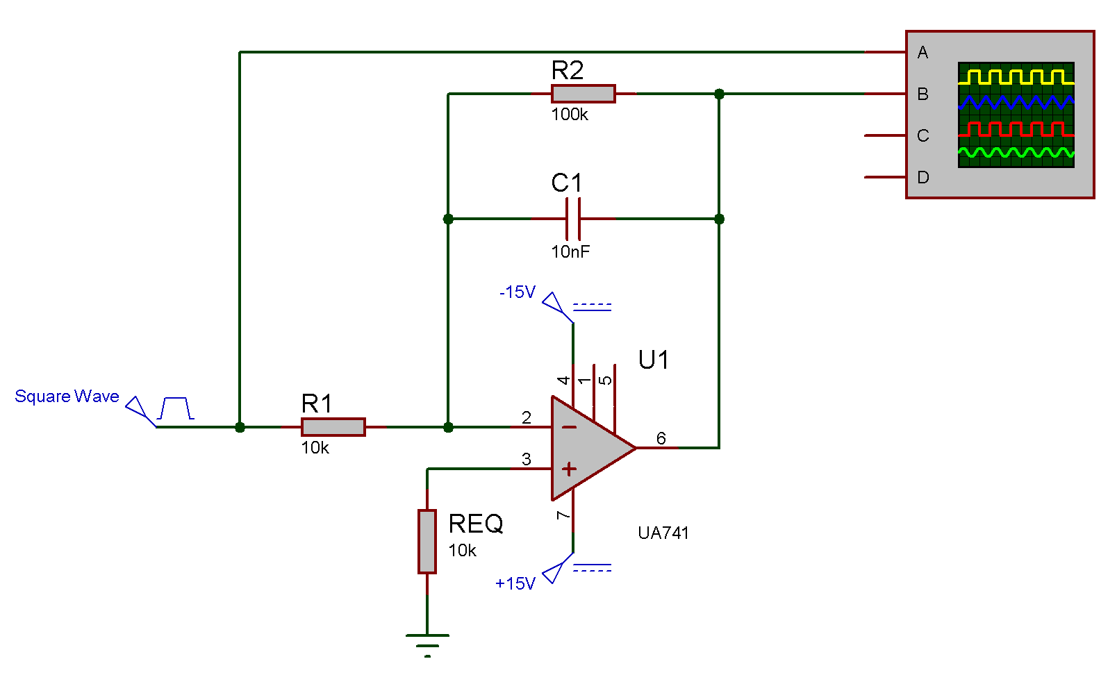

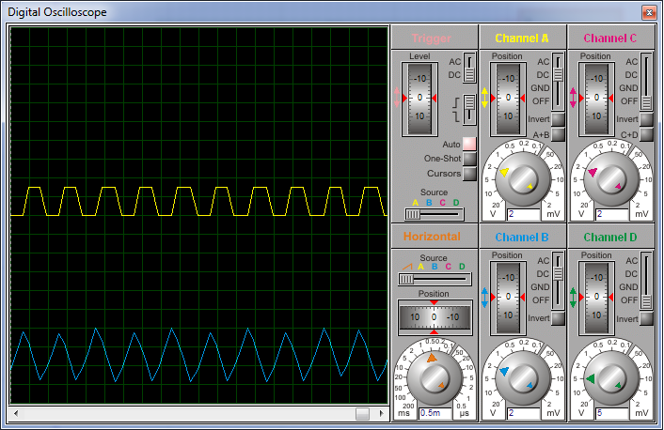

As can be seen in simulation oscilloscope screen; input signal 5V square wave as Vin (yellow line) and the output signal (blue line). Output is integral form of input signal, so integral form of square wave signal is rectangle wave signal.